P.O Box 30089-00100

Nairobi Kenya

Tel: [+254 741 088 144](http://12.173.120.123/)

Email: info@estateagentsboard.or.ke

Prism Tower 17th Floor,

3rd Ngong Avenue Off Ngong Road

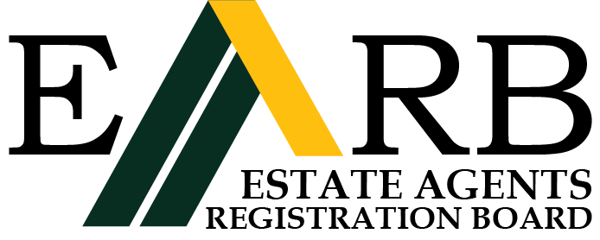

## STATUTORY DECLARATION'

(In compliance with the Estate Agents (Accountant's Certificate) Rules)

# I, .......................................................................................................................………….

(Full name as on the Estate Agents Registration Board Register)

# of ......................................................................... P. o. Box...............................................

## (Firm/Employer)

Do solemnly and sincerely declare as follows:

1. That I am an Estate Agent duly Registered on the................day of..................... 19/20……………….

My last Practising Certificate was issued on the……........... day of……………….19/20 and

expired on the thirty-first day of December19/20……... (OR)

**(OTHERWISE, STATE WHAT IS RELEVANT IN OWN PARTICULAR CIRCUMSTANCES)**

1. That during the period from ...............day of 19/20……… the Estate Agents (Accountant’s certificate) Rules did not apply to me because I did not during this period practise on my own account, either alone or in partnership, nor did I hold or receive client's money.
2. Depone what you were doing during the period in (2) above

……………………………………………………........................................................................................

(4) That I make this declaration conscientiously believing the same to be true and in accordance with the

Oaths and Statutory Declarations Act

**Declared at ...................................................this…..…..…….. Day……………….. of 20………………**

## BEFORE ME COMMISSIONER FOR OATHS

TO: The Registrar

**Estate Agents Registration Board**

**P.O. Box 30089,**

**NAIROBI**

**……………….**

**(DEPONENT)**