P.O Box 30089-00100
Nairobi Kenya
Tel: +254 741 088 144
Email: info@estateagentsboard.or.ke
Prism Tower 17th Floor,
3rd Ngong Avenue Off Ngong Road

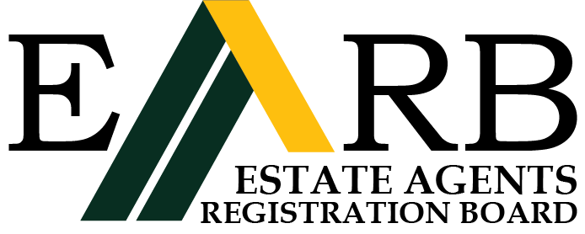

STATUTORY DECLARATION'
(In compliance with the Estate Agents (Accountant's Certificate) Rules)

I, .......................................................................................................................………….
(Full name as on the Estate Agents Registration Board Register)

of ......................................................................... P. o. Box...............................................

(Firm/Employer)

Do solemnly and sincerely declare as follows:
- That I am an Estate Agent duly Registered on the................day of..................... 19/20……………….

My last Practising Certificate was issued on the……........... day of……………….19/20 and

expired on the thirty-first day of December19/20……... (OR)

(OTHERWISE, STATE WHAT IS RELEVANT IN OWN PARTICULAR CIRCUMSTANCES)
- That during the period from ...............day of 19/20……… the Estate Agents (Accountant’s certificate) Rules did not apply to me because I did not during this period practise on my own account, either alone or in partnership, nor did I hold or receive client's money.

- Depone what you were doing during the period in (2) above
……………………………………………………........................................................................................

(4) That I make this declaration conscientiously believing the same to be true and in accordance with the

Oaths and Statutory Declarations Act

Declared at ...................................................this…..…..…….. Day……………….. of 20………………

BEFORE ME COMMISSIONER FOR OATHS
TO: The Registrar
Estate Agents Registration Board
P.O. Box 30089,
NAIROBI

……………….
(DEPONENT)

